Feedback Mechanisms
How do organisms regulate complex systems through chemical interactions?

The heating system of a house works to keep the temperature constant. If the house gets too cold, then the heat automatically turns on to warm the house. The heat stops when the preset temperature is reached. This is an example of a feedback mechanism. Organisms use many feedback mechanisms to either maintain or amplify important chemical systems. This could happen at a molecular level to coordinate the function of a single enzyme or it could happen throughout the body to regulate the organism’s internal temperature.

Model 1 – Positive and Negative Feedback

Message is sent. Message is sent.
Stimulus
Negative
Feedback
Response
Stimulus
Positive
Feedback
Response
Stimulus is decreased. Stimulus is increased.

- What two types of feedback mechanisms are illustrated in Model 1?

- Define the words below as they are used in everyday language.
Stimulus

Response
- How are the two types of feedback mechanisms in Model 1 SIMILAR?

- Imagine that you have just gotten a puppy. In the course of playing with the puppy you throw a ball and the puppy chases after it. You then say “Good job!” and rub the puppy’s head to show him he did what you wanted him to do this makes your puppy chase the ball more.
  - Is the puppy likely to chase the ball the next time you throw it? Justify your reasoning.

  - Identify the portions of the scenario as stimulus or response.
Puppy chases the ball.
“Good Job” and head rub.
  - Is this scenario an example of positive or negative feedback? Justify your reasoning using the words “stimulus” and “response.”

- Later that day your puppy urinates on the couch. You then say “No, bad dog!” and place the puppy outside.
  - Is the puppy likely to urinate on the couch again? Justify your reasoning.

  - Identify the portions of the scenario as stimulus or response.
Puppy urinates on the couch.
“No, bad dog!”
  - Is this scenario an example of positive or negative feedback? Justify your reasoning using the words “stimulus” and “response.”

- Which of the feedback mechanisms in Model 1 would be most useful for amplifying a condition that is advantageous for the organism?

- Which of the feedback mechanisms in Model 1 would be most useful for stopping a condition that is detrimental or limiting a condition to specified levels?

Model 2 – Thermoregulation in Humans
Hypothalamus in the brain senses that temperature is too low. Sends out signal
Temp
too low
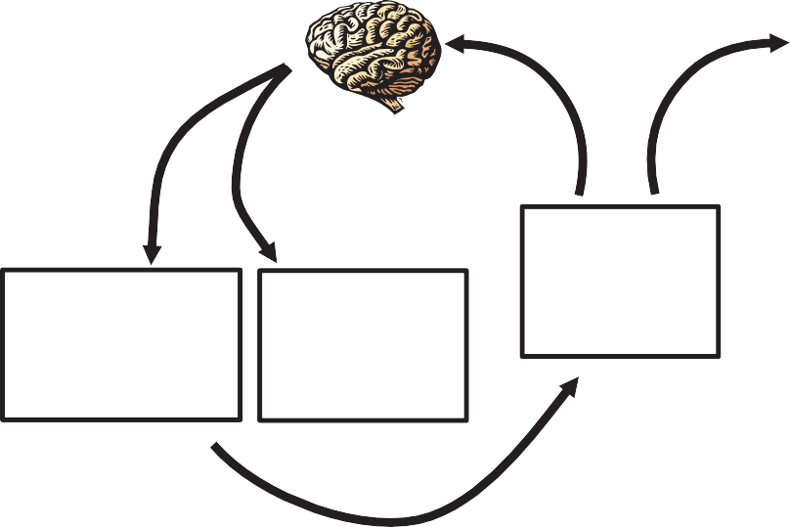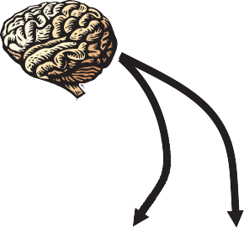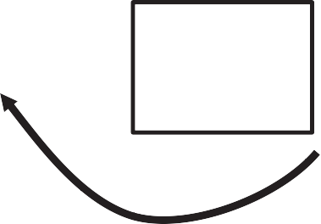to heat the body.

Temp. too high.

Hypothalamus in the brain senses that temperature is too high.
Sends out signals to cool the body.

Blood vessels in skin constrict, reducing heat loss.

Muscles begin to shiver, generating heat.
Normal Body Temperature 36 – 38 °C

Blood vessels in skin dilate to radiate heat.
Sweat glands increase sweat production.

Body temperature increases.

Body temperature decreases.

- Examine Model 2. Based on what you see in the model, propose a definition for “thermoregulation.”

- According to Model 2:
What are two mechanisms the body uses to cool itself?

What are two mechanisms the body uses to heat itself?

- Consider the feedback loop that cools the body when it is too warm.

Is this feedback loop positive or negative feedback? Justify your reasoning.

- Consider the feedback loop that cools the body when it is too cold.

Is this feedback loop positive or negative feedback? Justify your reasoning.

- Below are several descriptions of processes that occur in the human body. For each one identify the stimulus and the response and state whether the process is positive or negative feedback.
  - When human tissue, such as skin or a blood vessel, is torn or cut, the cells near the damage send out a signal that activates platelets in the vicinity. As the platelets begin to form a plug, they release more chemical signals to attract more platelets and other clotting factors until the bleeding is stopped.

  - When a person has not taken in sufficient water they become dehydrated. This may cause a loss of blood pressure, which will trigger the release of antidiuretic hormone (ADH) from the hypothalamus and pituitary glands. This hormone signals the kidney to allow reabsorption of water by the blood vessels to bring the blood pressure back to normal conditions.

  - When a human increases physical activity, the amount of fuel burned in its cells also increases, which in turn increases the concentration of dissolved CO2 in the blood. The CO2 reacts with water in the blood to make a weak acid, which lowers the pH of the blood. Sensory cells in
the medulla of the brain register this drop in pH and send signals to the diaphragm and heart to increase respiration. This will clear the CO2 from the bloodstream.

